Date: MAY 28 2021 File: C:\Karapetyan\18501 Нержавейка на ПКС - в расчет\03_program\6\18501 Нержавейка 6001.NST

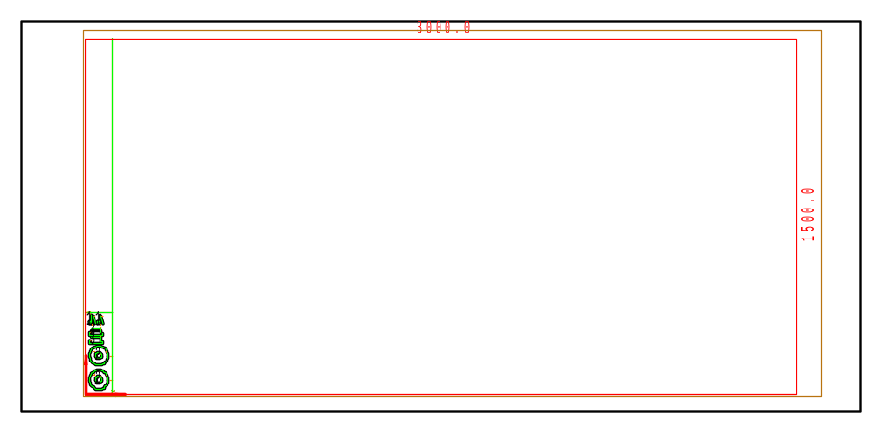

PART INFO
NC File Name: Ê!Å;Ä2RÅ1ÌÌ6001%ËÍ
Draft no.: | Version:
Order no.: | Description:
SHEET Number of sheets: 1
Material: Stainless | Sheet size: 3000 X 1500 | T= 6.0
No. of parts: 6 | Part size:
Part weight: | Sheet weight: 210.60 kg
MACHINE:
MODEL: ML3015EX |  | Con. name: SUS304 |  | Table name: ML45CF_R_EX
Gas: N2H | Lens: 7.5 Inches |  | Nozzle diameter: 2.5
Speed: 2000 |  | Used laser power: 4500 |  | Beam diameter (kerf): 0.36
PROGRAM
Number: 4165 | File size: 3205 | Programmer:
Notes:
JOB TIME (min:sec)
Travel: 00:06 | Cut: 01:41 | Pierce: 00:40
Travel way: 2125.4 mm | Cutting way: 0 mm | Pierce Qty.: 16
Total time: 02:26

 | Part name | DX | DY | QTY
2 | Ê#Å;32.70.04.01.048ÌÌ_ÌmËÍ | 90 | 90 | 2
3 | Ê#Å;32.70.04.01.122Ì_Ì~ËÍ | 60 | 25 | 2
1 | Ê#Å;32.70.04.01.019-21ÌÌ_Ì`ËÍ | 25 | 50 | 2

